Web-Based Satellite-Observed Mountain Snow-Cover Visualization Tool
Scope: Develop a web-based visualization tool to retrieve remotely sensed satellite snow cover data and calculate and display the interannually recurring snowmelt pattern for user-selected mountainous areas in Idaho.
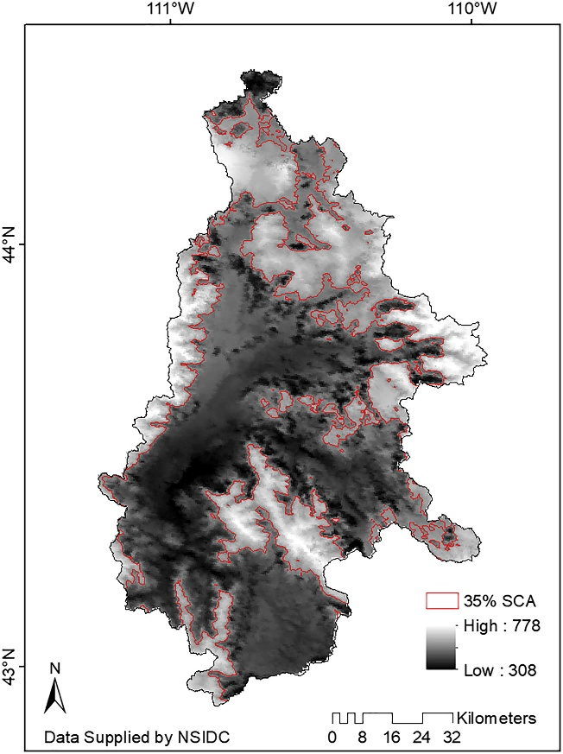
Background: Approximately 75 percent of the Idaho’s water supply comes from mountain snowmelt. Knowledge of how much snow is in the mountains and how fast it melts is crucial for water supply management and drought assessment by many state, federal and private organizations. Satellite remote sensing data observes mountain snow-covered area across the globe at 375 to 500 m spatial resolution on a daily basis. However when cloud-cover is present over a mountain watershed, no satellite data can be collected from that obscured area. Dr. Qualls’ (Chemical & Biological Engineering, University of Idaho) climate laboratory has developed a method to combine multiple years of remotely sensed satellite data to generate the interannually-recurring spatial pattern of snowmelt across mountainous areas; this pattern can be used to reprocess daily imagery containing cloud cover to infill the gaps in the image that are cloud covered with actual snow cover (Woodruff and Qualls, 2019). A simplified tool is needed for end-users to be able to generate this information without having to develop their own computer code. For this project, the design team will develop a web-based tool that allows a user to select a mountain watershed in Idaho, after which the tool will retrieve satellite imagery from the National Snow and Ice Data Center, generate the annually recurring spatial snowmelt pattern, display the pattern and allow the user to download an image file (e.g. geo-referenced TIF file). As time allows, the project can be expanded to allow the user to specify a particular date, and have the web tool retrieve and cloud-gap-fill the snow cover image file for their specified watershed and date.
Figure 1. Example of the Interannually-recurring snowmelt pattern generated for the Snake River Headwaters. Darker colors indicate earlier melt, and lighter colors indicate later melt during the spring snowmelt period (Woodruff & Qualls, 2019).

It is anticipated that this web tool will be used by the Idaho Department of Water Resources, Idaho Office of Emergency Management, NRCS SNOTEL, US Army Corps of Engineers, Idaho Power, National Weather Service and other agencies for water and drought management. This is a great opportunity for a senior design team to develop a high-profile project with significant state-wide impacts.
Specific Design Requirements:
Develop web-tool that can
- Display map of Idaho for a user to select a particular Idaho watershed for processing and the satellite platform they would like to work with.
- Retrieve daily remotely sensed satellite data spanning many years from the National Snow and Ice Data Center (NSIDC).
- Allow the user to choose between two different satellite data sources (MODIS or VIIRS)
- Process the satellite data to generate the interannually recurring snowmelt pattern.
- Display the resulting image on an Idaho map.
- Allow the user to download a georeferenced image file of the pattern.
- Host the web-tool on a publicly-accessible platform to be specified by the project sponsor.
- Modify the tool based on end-user input to ensure user-friendliness of the finalized web tool.
- Use Python or other open-source language.
- Product should be coded so that others could expand the work to other states or regions of the world.
- As time allows, extend the web-tool to retrieve and cloud-gap-fill satellite images for individual user-selected days.
Students: CS

